**Image Processing**

**Assignment 1**

**Repository Link(Repo) :**

<https://github.com/Mohamed-abbes03/Assignment-1->

**Team:10**

**Snapshot 1: Raw Source IDs**

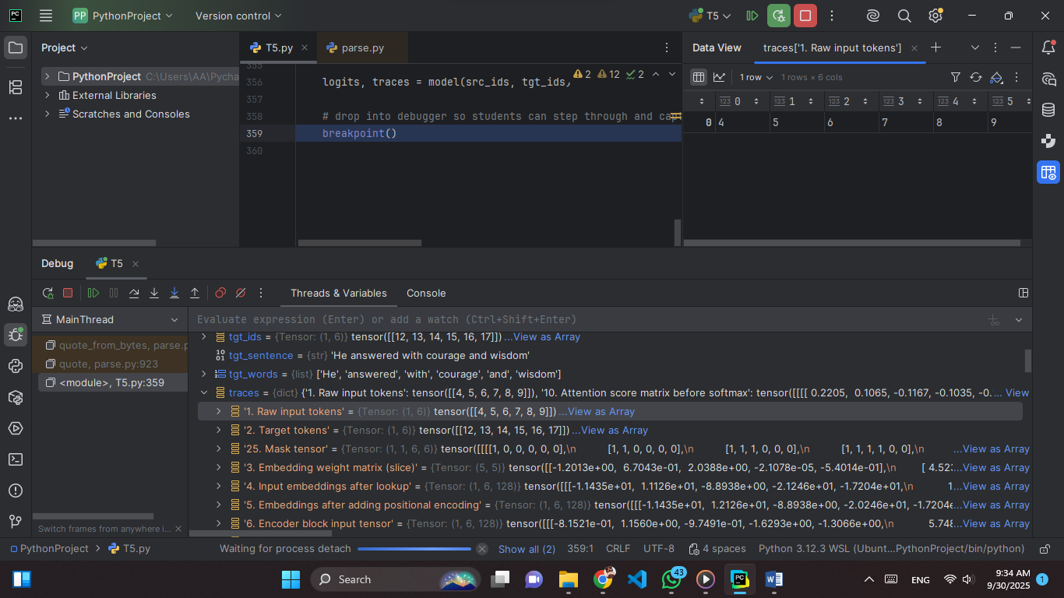

**Explain:** These are the raw input tokens of the source sentence after tokenization. Each word has been mapped to an integer ID from the model’s vocabulary. At this stage, the numbers carry no semantic meaning; they simply act as lookup indices for the embedding matrix. This is the very first step in the Transformer pipeline, before embeddings or positional encodings are applied.

**Values:** [[4, 5, 6, 7, 8, 9]]

**Tensor:** Shape (1, 6) → [batch size = 1, sequence length = 6]

### Snapshot 2: Raw Target IDs

### 

**Explain:** These are the token IDs of the target sentence. They serve two roles: as input to the decoder (after embedding) and as the ground truth for computing the training loss. Just like the source IDs, these integers are indices into the embedding table, not meaningful on their own. This marks the starting point of the decoding side of the Transformer.

**Values:** [[12, 13, 14, 15, 16, 17]]

**Tensor:** Shape (1, 6) → [batch size = 1, sequence length = 6]

### Snapshot 3: Embedding Weights Matrix

**Explain:** This is the embedding weight matrix for the source vocabulary. Each row corresponds to one token ID, and each row vector is the dense representation of that token. When the model sees a token ID, it uses it to select the matching row from this matrix. These vectors are trainable parameters that allow the model to capture semantic meaning and relationships between tokens.

**Values(just part):**  
-1.20126, 0.67043, 2.03885, -0.00002, -0.54014  
0.45237, 0.00212, 0.66064, -0.91999, -0.79783

These are continuous real numbers, typically ranging between -2.0 and +2.0 depending on initialization. Each row is one embedding vector.

**Tensor:** Shape (20, 16) → [vocab size = 20, embedding dimension = 16].

### Snapshot 4: Source Embeddings

**Explain:** These are the dense continuous vectors for the raw source token IDs. Each ID was used to index into the embedding weight matrix, retrieving the corresponding row. This converts the discrete tokens into semantic representations that the model can process. These embeddings will then be combined with positional encodings in the next step.

**Values (just part):**  
-11.43507, 11.12635, -8.89382, -21.24598, -17.20373  
3.96968, 18.78245, -3.04635, 3.45485, 1.87704

(continuous real values, not integers. Typically range between -30 and +30 here because embeddings + initialization + training shift the values).

**Tensor:** Shape (1, 6, 128) → [batch size = 1, sequence length = 6, embedding dimension = 128].

### Snapshot 5: Embeddings + Positional Encoding

### 

**Explain:** These are the source embeddings after adding positional encoding. The positional encoding injects order information into the sequence by adding a unique position-dependent vector to each token embedding. This ensures the model knows not only what each token represents, but also **where** it occurs in the sequence. Without positional encoding, the model would treat the input as a bag of words with no order.

**Values (just part):**  
-11.43507, 12.12635, -8.89382, -20.24598, -17.20373  
3.96968, 19.78245, -3.04635, 4.45485, 1.87704

(continuous real numbers; here the range shifted slightly compared to Snapshot 4, approximately between -30 and +30). Each number = embedding value + positional encoding value.

**Tensor:** Shape (1, 6, 128) → [batch size = 1, sequence length = 6, embedding dimension = 128].

### Snapshot 6: Encoder Input Tensor

### 

**Explain:** This tensor represents the **prepared input embeddings with positional encoding** (from Snapshot 5) as they enter the **first encoder block**. At this stage, the model now has both semantic meaning (from embeddings) and word order (from positional encoding). The tensor is the direct input to the encoder’s **multi-head self-attention layer**, where contextual relationships between tokens will start being modeled.

**Values (just part):**

-0.81521, 1.15596, -0.97491, -1.62933, -1.30659,   
1.66251, -0.52154, -1.00136, 0.35145, -1.99838,

(continuous real values, roughly ranging between -3.0 and +3.0. Each row corresponds to one token’s embedding vector after encoding).

**Tensor:** Shape (1, 6, 128) → [batch size = 1, sequence length = 6, embedding dimension = 128].

### Snapshot 7: Self-Attention Queries (Q)

**Explain:** This tensor contains the **query vectors (Q)** computed from the encoder input using a learned linear projection. Each token’s embedding is mapped into a lower-dimensional **query space** (here, 32 dimensions per head) that will later interact with keys (K) to compute attention scores.

**Values (just part):**  
0.17810, 0.49154, 0.90288, -0.39698, -0.07155, 0.49909,  
-0.45267, -0.77141, 0.72647, -0.02992, -1.23508, -0.96090,

(values are smaller, roughly between -1.5 and +1.5, because they come from a linear projection + normalization).

**Tensor:** Shape (1, 4, 6, 32) → [batch size = 1, heads = 4, sequence length = 6, head dimension = 32].

### Snapshot 8: Self-Attention Keys (K)

**Explain:** This tensor contains the **key vectors (K)** for each token. Keys are produced by applying another learned linear projection to the encoder input (similar to queries, but with different weights). During attention, each query compares itself against all keys via a dot product, which measures **how much focus a token should give to others**.

**Values (just part):**  
-0.40565, 0.58514, -0.53025, -0.30586, -0.09096, 0.02167,   
-0.75564, 1.07195, 0.21593, -0.24405, 0.25145, -0.48856,

(values typically range between about -1.5 and +1.5, coming from the linear transform).

**Tensor:** Shape (1, 4, 6, 32) → [batch size = 1, heads = 4, sequence length = 6, head dimension = 32].

### Snapshot 9: Self-Attention Values (V)

**Explain:** This tensor contains the **value vectors (V)** for each token. Values are another linear projection of the input embeddings. After the attention mechanism computes attention weights (using Q·Kᵀ), those weights are applied to the values. In other words, the **values carry the actual information** that gets passed forward, while queries and keys only determine where to focus.

**Values (just part):**  
0.99316, 0.51250, 0.36996, 0.07291, 0.48165, -0.95568,   
-0.04011, -0.17265, -0.50928, 1.12647, 0.74039, -0.60141,

(numbers range roughly between -2.0 and +1.5, due to learned weights and input variability).

**Tensor:** Shape (1, 4, 6, 32) → [batch size = 1, heads = 4, sequence length = 6, head dimension = 32].

### Snapshot 10: Attention Score Matrix Before Softmax

**Explain:** This tensor holds the **raw attention scores** computed by the dot product between queries (Q) and keys (K). These scores represent how much focus each query token should place on every key token. At this stage, the values are **not yet normalized**. After this, the scores are typically scaled (by √dₖ) and then passed through the **softmax** function to produce the actual attention weights.

**Values:**  
0.22045, 0.10647, -0.11666, -0.10355, -0.13954, 0.68587  
0.05039, -0.11979, 0.27352, 0.16319, -0.53269, 0.34524

(numbers can be positive or negative; range depends on input and dimensionality, often within about -1.0 to +1.0 before scaling).

**Tensor:** Shape **(1, 4, 6, 6)** → [batch size = 1, heads = 4, query length = 6, key length = 6].

### Snapshot 11: Attention Score Matrix After Softmax

### 

**Explain:** This tensor contains the **normalized attention weights**, obtained by applying the **softmax function** to the raw attention scores. Each row sums to **1.0**, turning raw scores into a probability distribution that indicates how much each query token attends to every key token. These weights are later used to compute the weighted sum of the values (V).

**Values:**  
0.17795, 0.15878, 0.12702, 0.12870, 0.12415, 0.28341  
0.16356, 0.13796, 0.20445, 0.18309, 0.09129, 0.21965

(numbers are all positive, between 0 and 1, with each row summing to 1.0).

**Tensor:** Shape **(1, 4, 6, 6)** → [batch size = 1, heads = 4, query length = 6, key length = 6].

### Snapshot 12: Multi-Head Split (Q/K/V Split)

**Explain:** This tensor shows the query, key, and value (Q/K/V) projections after being split across multiple attention heads. Instead of keeping all features in a single high-dimensional space, the model divides them into smaller “heads.” Each head processes a different subspace of the embedding dimension, enabling the model to capture diverse types of relationships in the sequence.

**Values (just part):**  
1.7810e-01, 4.9154e-01, 9.0288e-01, -3.9698e-01, -7.1552e-02,  
4.9909e-01, 1.0582e-01, 4.2094e-01, -2.8908e-01, 6.1592e-01,

**Tensor:** Shape (1, 4, 6, 32) → [batch size = 1, heads = 4, sequence length = 6, head dimension = 32].

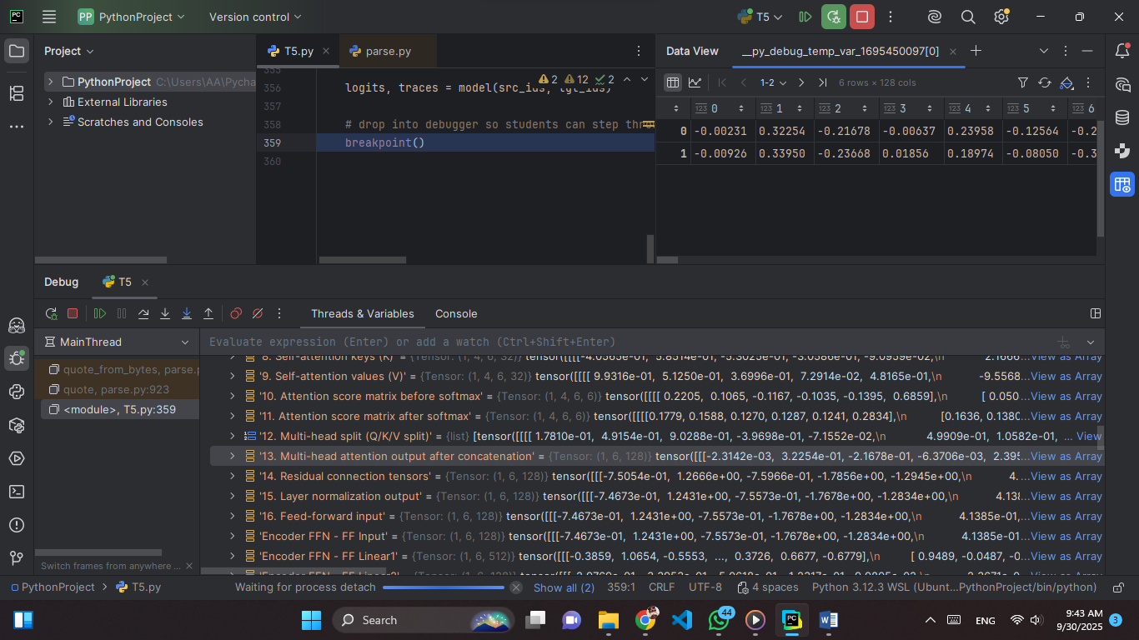**Snapshot 13: Multi-Head Attention Output After Concatenation**

**Explain:** This tensor represents the final output of the **multi-head attention mechanism** after the results of all heads have been concatenated together. Each attention head processes the sequence independently in its own subspace, and then the model concatenates their outputs along the feature dimension. This merged representation combines diverse relational patterns, which will then be passed through a linear projection to integrate them into the model’s main embedding space.

**Values (just part):**  
-0.00231, 0.32254, -0.21678, -0.00637, 0.23958, -0.12564,   
-0.00926, 0.33950, -0.23668, 0.01856, 0.18974, -0.08050,

(numbers range roughly between −1.0 and +1.0, as they are weighted sums of values across heads).

**Tensor:** Shape (1, 6, 128) → [batch size = 1, sequence length = 6, concatenated head dimension = 128]

**Snapshot 14: Residual Connection Tensors**

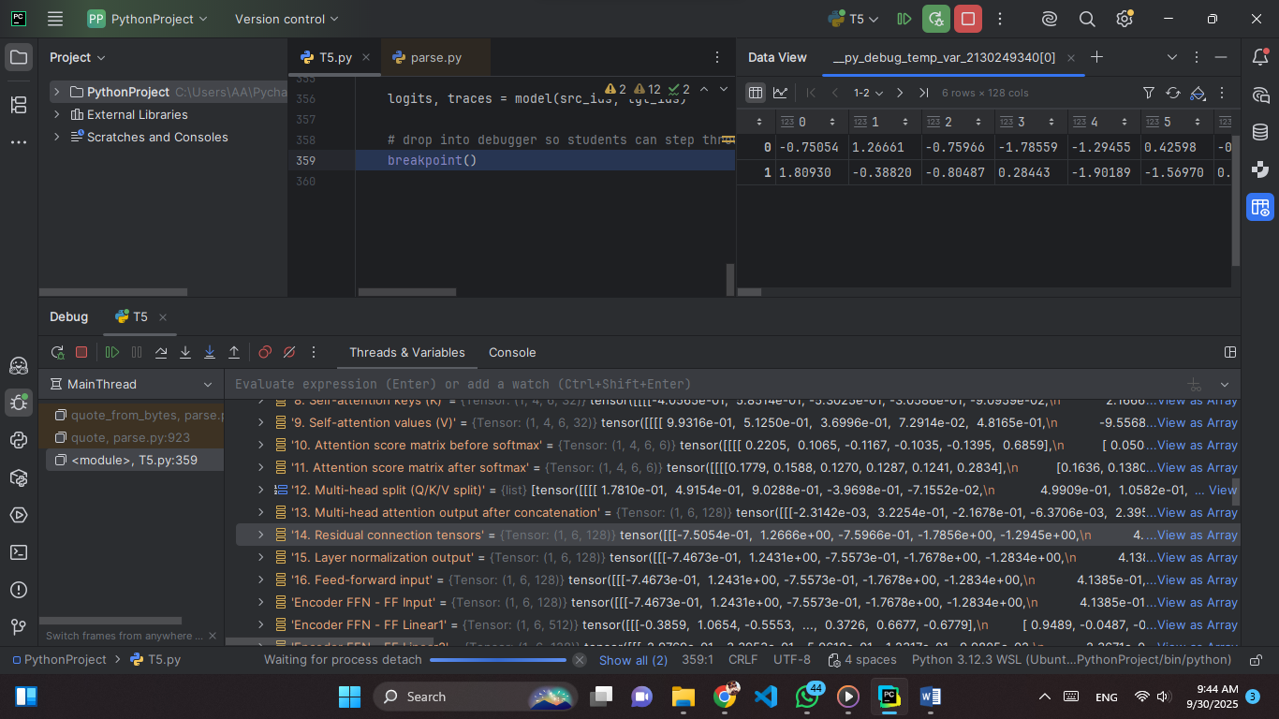

**Explain:** This tensor represents the **residual connection** in the Transformer. A residual (or skip) connection adds the original input of a sublayer (e.g., attention or feed-forward block) back to its output. This technique helps the model preserve the original signal while allowing deeper transformations. It stabilizes training, prevents vanishing gradients, and allows both new features (from attention/FFN) and old features (from the input embedding) to coexist.

**Values (just part):**  
0.00000, -0.75054, 1.26661, -0.75966, -1.78559, -1.29455,   
1.00000, 1.80930, -0.38820, -0.80487, 0.28443, -1.90189,

(values range from roughly −2.5 to +2.8, showing the effect of combining outputs with the original input signal).

**Tensor:** Shape (1, 6, 128) → batch size 1, sequence length 6, feature dimension 128.

**Snapshot 15: Layer Normalization Output**

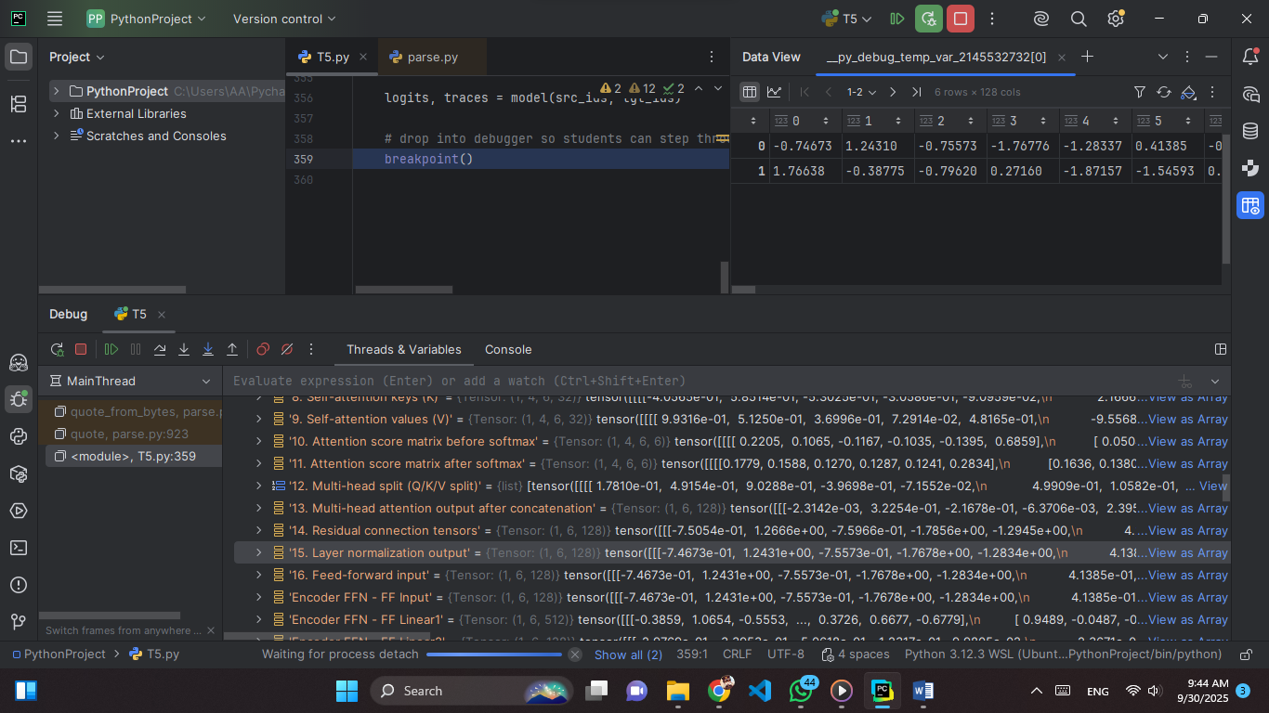

**Explain:** This tensor represents the result of applying **Layer Normalization** inside the Transformer. Layer normalization standardizes the values across the feature dimension (hidden size = 128 here) for each token, ensuring that the mean is close to 0 and variance close to 1. This stabilizes training, makes optimization easier, and prevents activations from drifting too far across layers.

**Values (just part):**  
0.00000, -0.74673, 1.24310, -0.75573, -1.76776, -1.28337,   
1.00000, 1.76638, -0.38775, -0.79620, 0.27160, -1.87157,

(values range from roughly −2.3 to +2.7, showing normalized activations centered around 0 with unit variance).

**Tensor:** Shape (1, 6, 128) → batch size = 1, sequence length = 6 tokens, hidden dimension = 128 features.

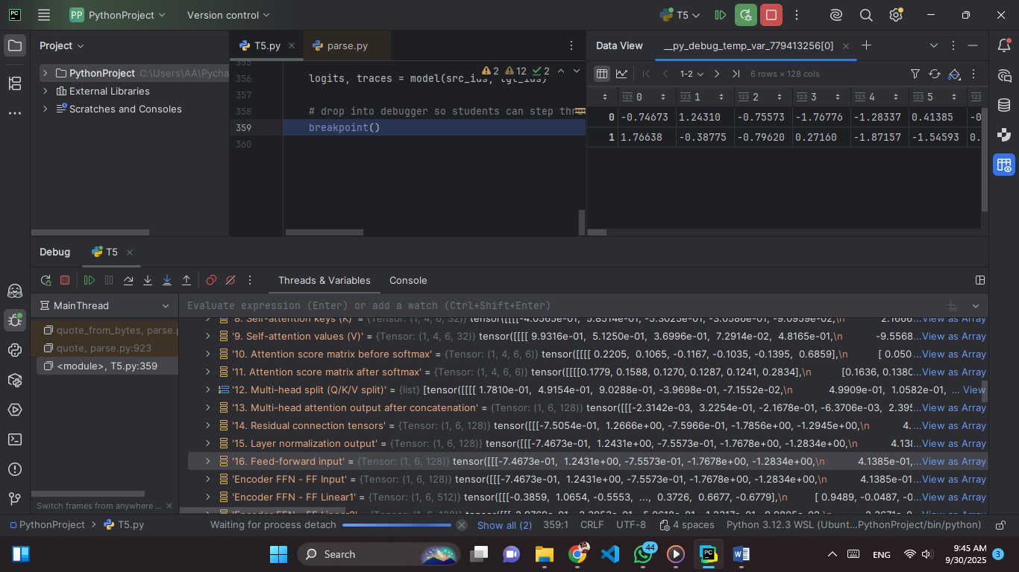**Snapshot 16: Feed-forward Input**

**Explain:** This tensor represents the **input to the Feed-Forward Network (FFN)** in the Transformer encoder block. After self-attention and layer normalization, each token’s embedding is passed into the FFN, which consists of two linear transformations with a ReLU (or GELU) nonlinearity in between.

**Values (just part):**  
-0.74673, 1.24310, -0.75573, -1.76776, -1.28337, 0.41385,   
1.76638, -0.38775, -0.79620, 0.27160, -1.87157, -1.54593,

(values range from about −2.3 to +2.8, showing normalized but still diverse activations ready for nonlinear transformation).

**Tensor:** Shape **(1, 6, 128)** → batch size = 1, sequence length = 6 tokens, hidden dimension = 128 features.

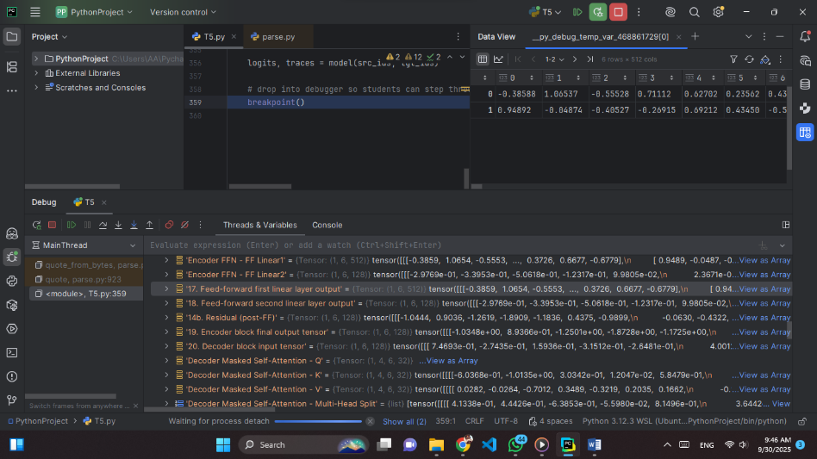**Snapshot 17: Feed-forward First Linear Layer Output**

**Explain:**  
This tensor represents the **output of the first linear transformation** inside the Feed-Forward Network (FFN). The FFN typically has two steps:Expand the hidden dimension (often 4× larger) and Apply a nonlinearity (ReLU/GELU). At this stage, the input (dimension 128) is projected into a much higher-dimensional space (dimension 512 here). This expansion allows the network to represent more complex transformations and interactions between features.

**Values (just part):**  
-0.38588, 1.06537, -0.55528, 0.71112, 0.62702, 0.23562,   
0.09545, -0.57024, -0.43865, -0.65744, 0.20069, 0.18112,

(values range from about **−1.7 to +1.5**, showing a spread that will later be passed through GELU/ReLU to introduce nonlinearity).

**Tensor:**  
Shape **(1, 6, 512)** → batch size = 1, sequence length = 6 tokens, expanded hidden dimension = 512 features.

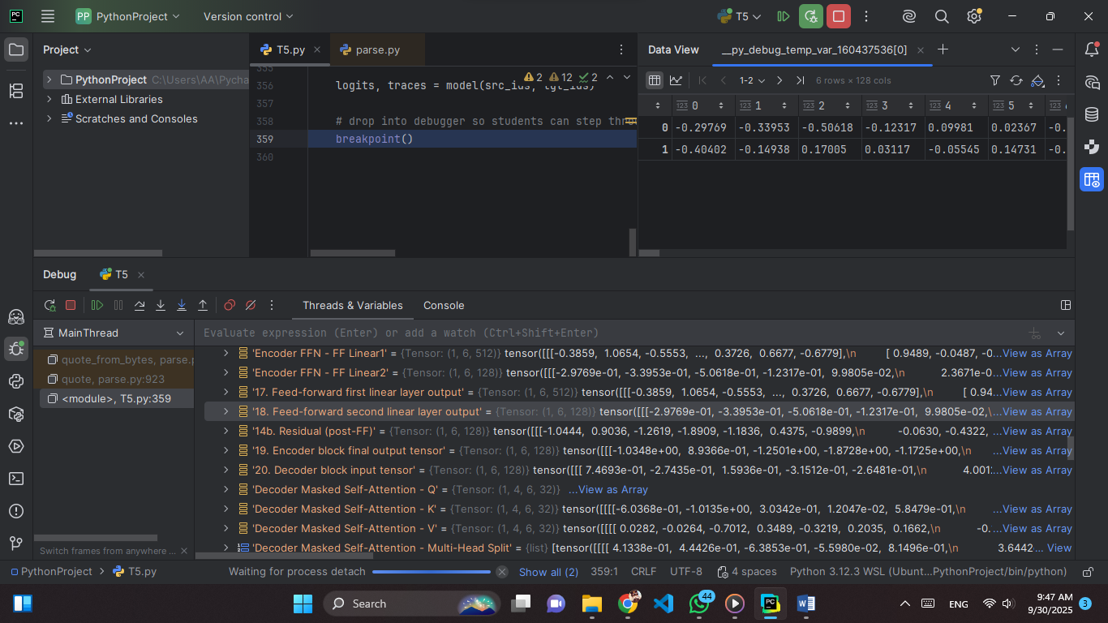**Snapshot 18: Feed-forward Second Linear Layer Output**

**Explain:** This tensor represents the **output of the second linear transformation** in the Feed-Forward Network (FFN). After the first linear layer expands the hidden dimension (128 → 512) and applies a nonlinearity (ReLU/GELU), the second linear layer projects the representation back down to the model’s hidden size (512 → 128). This step ensures that the dimensionality matches the rest of the Transformer, so the FFN’s enriched representations can be combined with the residual connection. At this point, the activations are more refined and compact, ready to be added back to the original input before layer normalization.

**Values (just part):**  
-0.29769, -0.33953, -0.50618, -0.12317, 0.09981, 0.02367,   
-0.40402, -0.14938, 0.17005, 0.03117, -0.05545, 0.14731,

(values range from about **−0.66 to +0.78**, showing compressed activations aligned with the hidden dimension size).

**Tensor:** Shape **(1, 6, 128)** → batch size = 1, sequence length = 6 tokens, hidden dimension = 128 features.

**Snapshot 19: Encoder Block Final Output Tensor**

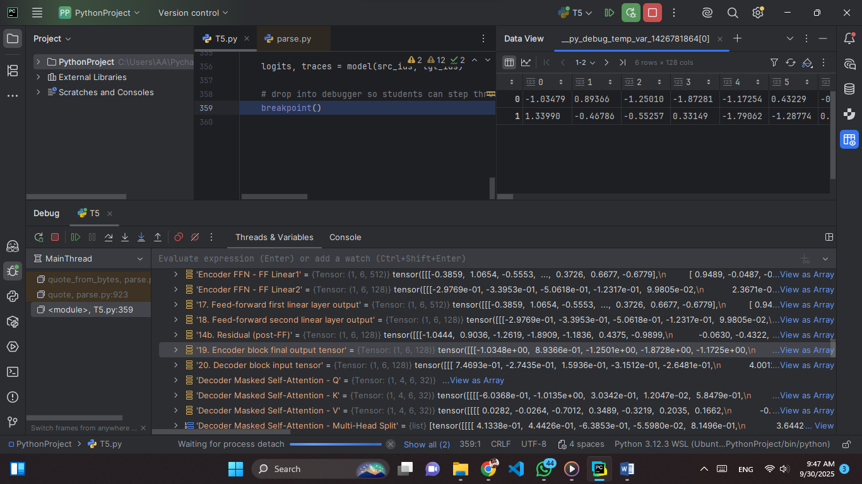

**Explain:** This tensor represents the **final output of a single encoder block** after all its sub-layers (multi-head self-attention + feed-forward + residual connections + layer normalization). At this stage, each token’s embedding has been contextualized: Self-attention allowed every token to integrate information from all other tokens, The feed-forward network refined these relationships, adding non-linear transformations, and Residual connections and layer normalization stabilized the representation, ensuring gradients flow smoothly during training.

**Values (just part):**  
-1.03479, 0.89366, -1.25010, -1.87281, -1.17254, 0.43229,   
-0.42872, 0.68447, -1.02026, 1.22237, 1.31409, -1.25949,

(values range roughly from **−2.74 to +2.70**, showing higher variance due to layer normalization at the end).

**Tensor:** Shape **(1, 6, 128)** → batch size = 1, sequence length = 6 tokens, hidden dimension = 128 features.

**Snapshot 20: Decoder Block Input Tensor**

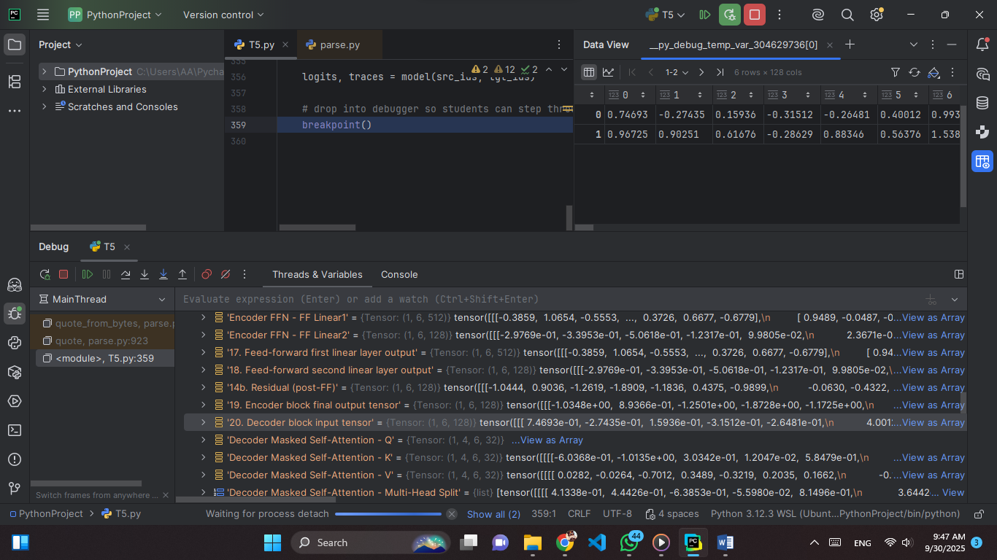

**Explain:** This tensor is the **starting point of the decoder**. It comes from the **target sequence embeddings** plus positional encoding. Each row is a token representation (128 features). From here, the decoder applies: **Masked self-attention** (looks only at past tokens) , **Cross-attention** (uses encoder outputs), and **Feed-forward + residual connections**.

**Values (just part):**  
0.74693, -0.27435, 0.15936, -0.31512, 0.40012, 0.99336,   
0.47970, -0.01151, -1.58268, 0.40771, 1.79254, -0.43201,

(values range from **−2.60 to +3.20**).

**Tensor:** Shape **(1, 6, 128)** → 1 sequence, 6 tokens, 128 features.

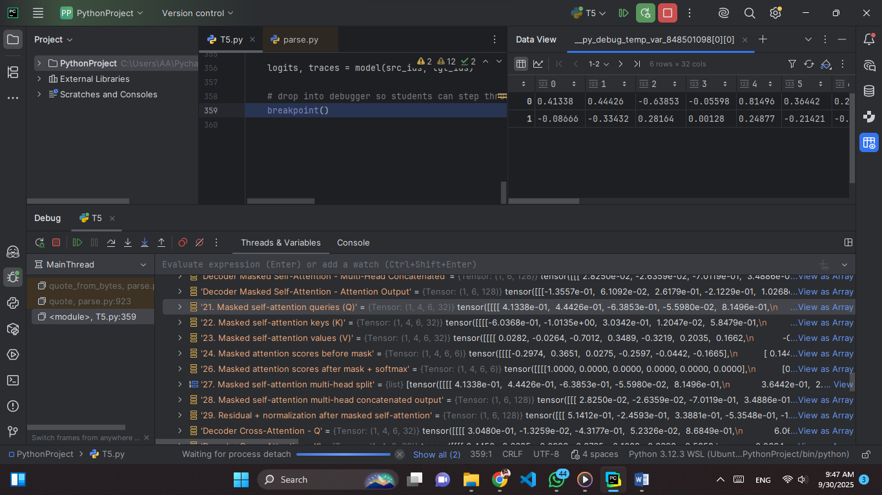**Snapshot 21: Masked Self-Attention Queries (Q)**

**Explain:** These are the **query vectors (Q)** used in the masked self-attention of the decoder. They are produced by a linear projection of the decoder input (Snapshot 20) and represent the “questions” that each token asks to find relevant information from previous tokens. The mask ensures that a token can only attend to itself and earlier tokens, preventing it from looking ahead in the sequence. Later, these queries will interact with the **keys (K)** to calculate attention scores, which determine how much focus each token should place on earlier ones.

**Values (just part):**  
0.41338, 0.44426, -0.63853, -0.05598, 0.81496, 0.36442, 0.22676, -0.51908,  
-0.08666, -0.33432, 0.28164, 0.00128, 0.24877, -0.21421, -0.62795, 0.10067

(values range from about **−1.21 to +1.15**).

**Tensor:** Shape **(1, 4, 6, 32)** → 1 sequence, 4 heads, 6 tokens, 32 features per head.

**Snapshot 22: Masked Self-Attention Keys (K)**

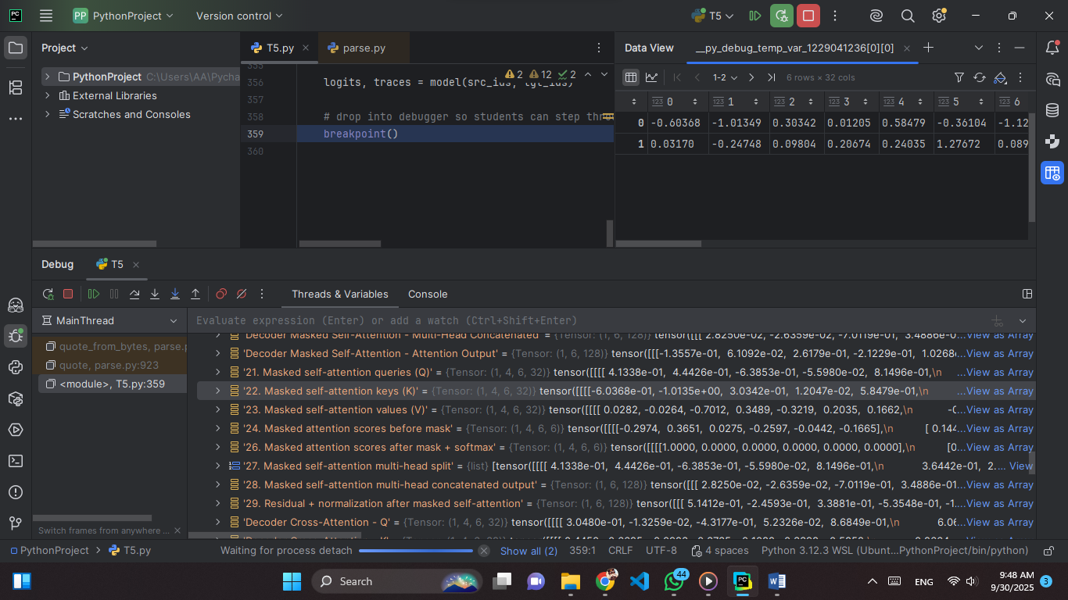

**Explain:** These are the **key vectors (K)** in the masked self-attention mechanism of the decoder. Keys are generated by linearly projecting the decoder input, just like queries, but instead of asking questions, they represent the “labels” or “addresses” that queries compare themselves against. During attention, each query is matched with all keys to produce similarity scores, which indicate how relevant each past token is. With the causal mask applied, a token can only use keys from itself and earlier tokens, ensuring predictions remain autoregressive.

**Values (just part):**  
-0.60368, -1.01349, 0.30342, 0.01205, 0.58479, -0.36104,  
0.03170, -0.24748, 0.09804, 0.20674, 0.24035, 1.27672,

(values range from about **−1.25 to +1.35**).

**Tensor:** Shape **(1, 4, 6, 32)** → 1 sequence, 4 heads, 6 tokens, 32 features per head.

**Snapshot 23: Masked self-attention values (V).**

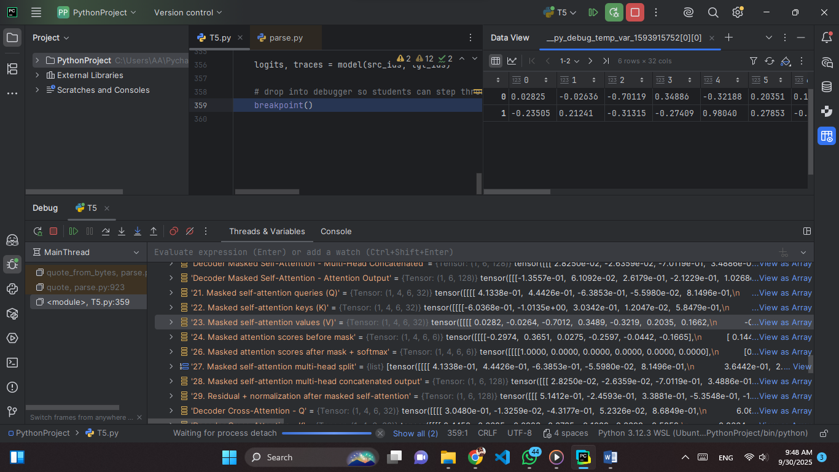

**Explain:** These are the value vectors (V) in the masked self-attention mechanism of the decoder. Values are generated by linearly projecting the decoder input, just like queries and keys, but instead of being compared, they carry the actual semantic content that will be aggregated. When attention weights are applied to values, they determine what information from past tokens is passed forward into the current context. With masking, each token can only draw value information from itself and earlier tokens, preserving the autoregressive nature of decoding.

**Values (part):**  
0.02825, -0.02636, -0.70119, 0.34886, -0.32188, 0.20351,  
-0.23505, 0.21241, -0.31315, -0.27409, 0.98040, 0.27853,  
(values range from about −1.95 to +1.17).

**Tensor:** Shape (1, 4, 6, 32) → 1 sequence, 4 heads, 6 tokens, 32 features per head.

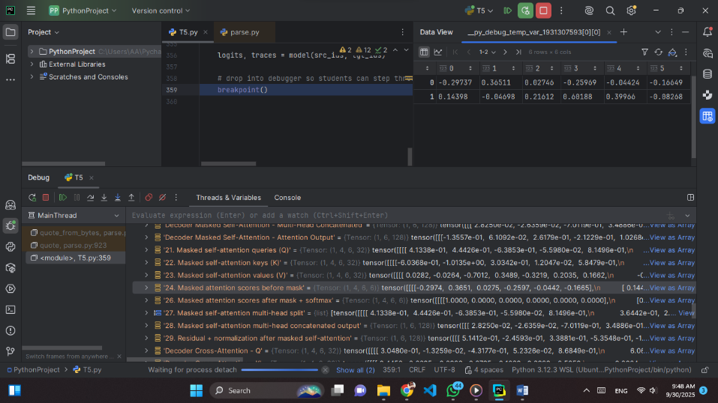 **Snapshot 24: Masked attention scores before mask.**

**Explain:** These are the raw attention scores computed as the dot product between queries (Q) and keys (K), before applying the causal mask. They represent the unnormalized similarity between each token’s query and all other tokens’ keys, essentially measuring how much one token “pays attention” to another. At this stage, the model can technically attend to future tokens, but the mask will later block those connections to preserve autoregressive decoding.

**Values:**  
-0.29737, 0.36511, 0.02746, -0.25969, -0.04424, -0.16649  
0.14398, -0.04698, 0.21612, 0.60188, 0.39966, -0.08268  
(values range roughly between −0.30 and +0.60).

**Tensor:** Shape (1, 4, 6, 6) → 1 sequence, 4 heads, 6 queries × 6 keys per head.

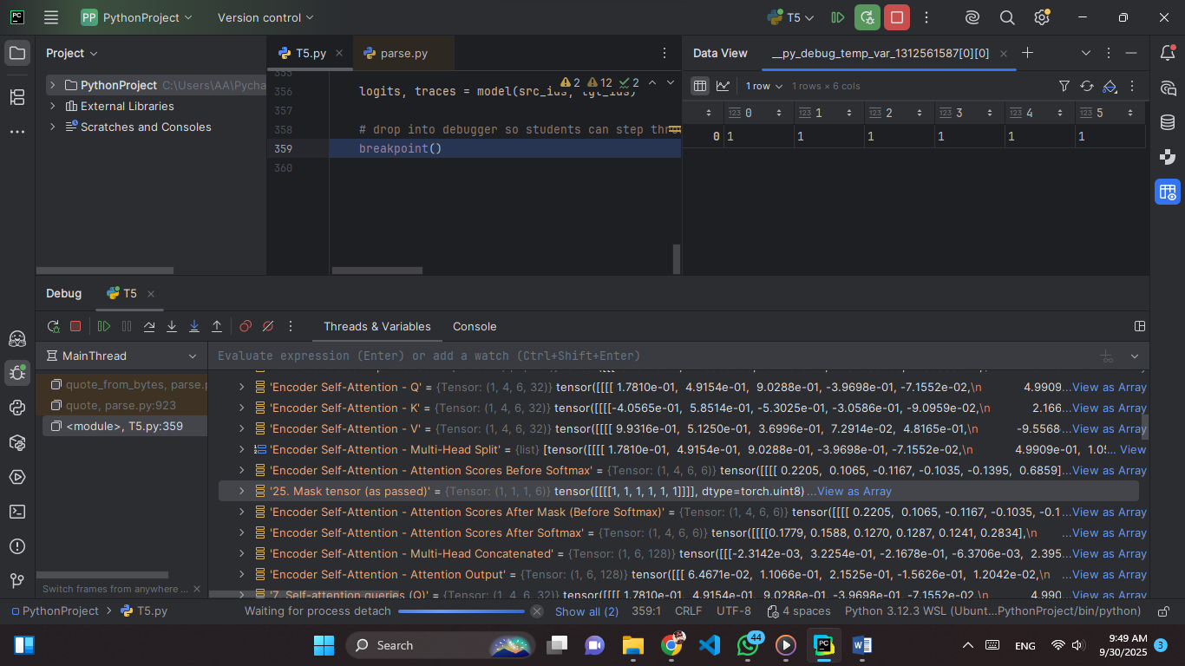 **Snapshot 25: Mask tensor.**

**Explain:** This is the causal mask applied to the attention scores in the decoder. The mask ensures that each token can only attend to itself and earlier tokens, preventing any “information leakage” from future tokens during autoregressive generation. A value of 1 means the position is allowed (visible), while 0 means the position is masked (inaccessible). This maintains the left-to-right prediction flow.

**Values:**  
1, 0, 0, 0, 0, 0  
1, 1, 0, 0, 0, 0  
(values are strictly 0 or 1).

**Tensor:** Shape (1, 1, 6, 6) → 1 sequence, 1 mask matrix, 6 queries × 6 keys.

**Snapshot 26: Masked attention scores after mask + softmax.**

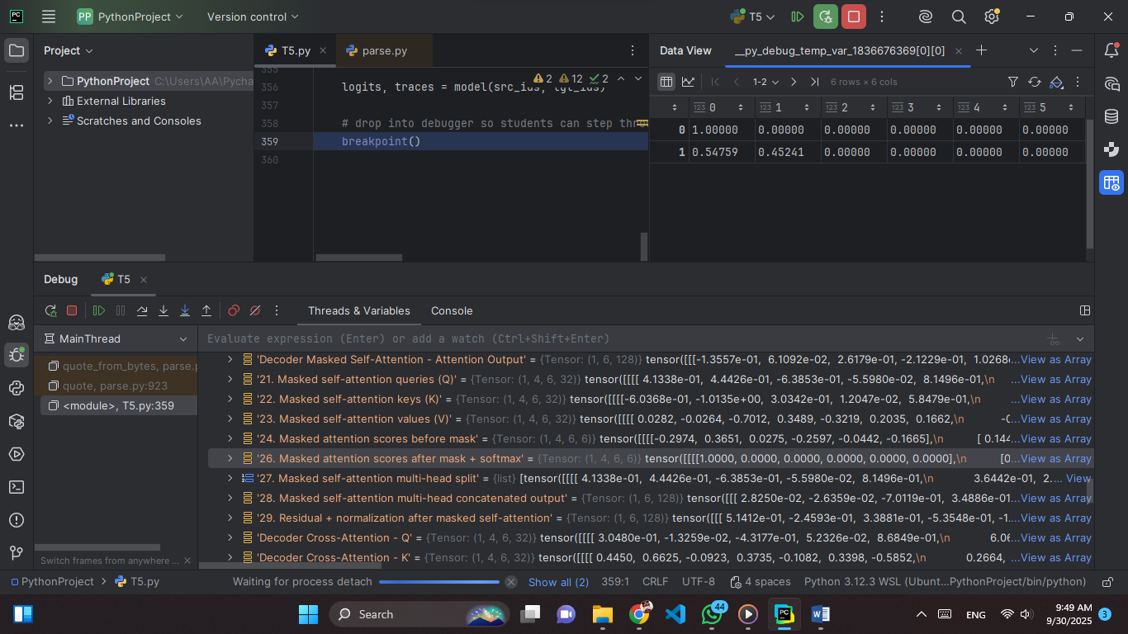

**Explain:** These are the attention weights after applying the causal mask and the softmax function. The mask sets future positions to zero, and the softmax normalizes the visible scores into probabilities that sum to 1. These values represent how much attention each token gives to itself and its allowed past tokens. Zeros indicate completely masked-out positions, while nonzero values show the distribution of attention among valid tokens.

**Values:**  
1.00000, 0.00000, 0.00000, 0.00000, 0.00000, 0.00000  
0.54759, 0.45241, 0.00000, 0.00000, 0.00000, 0.00000  
(values range between 0.0 and 1.0, normalized per row).

**Tensor:** Shape (1, 4, 6, 6) → 1 sequence, 4 heads, 6 queries × 6 keys.

**Snapshot 27: Masked self-attention multi-head split**

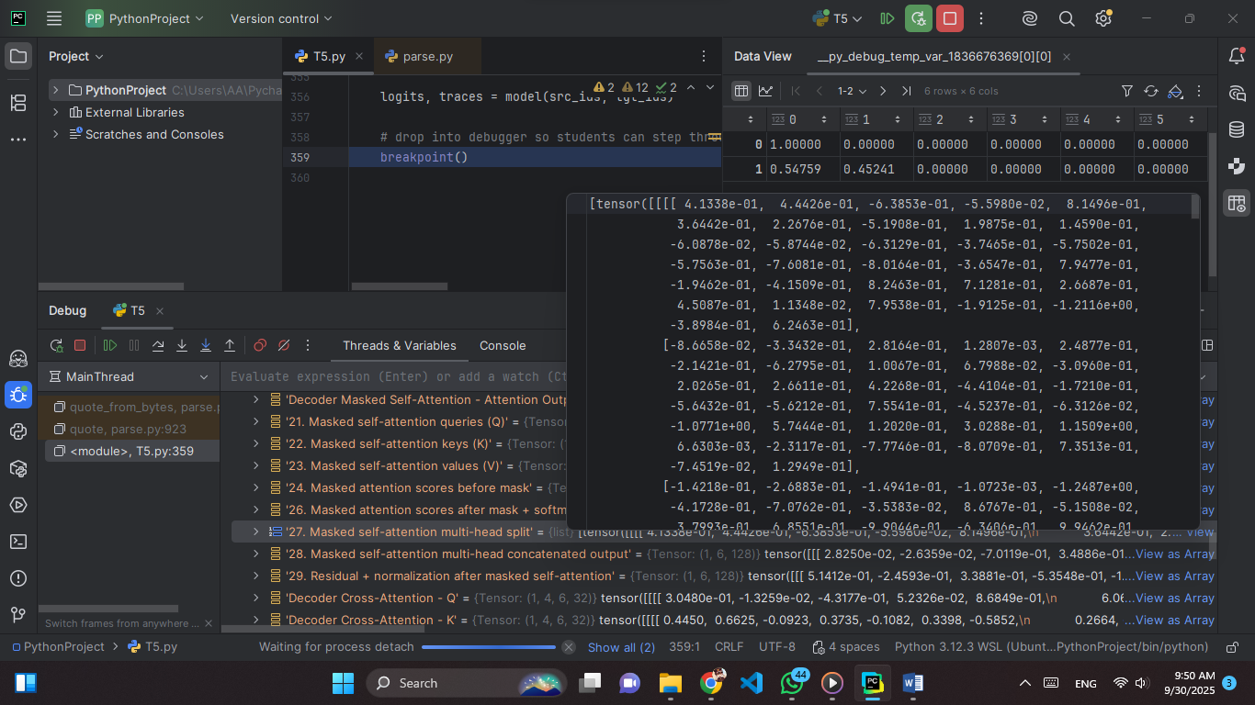

**Explain:** This step divides the query, key, and value projections into multiple attention heads so that each head can capture different contextual relationships in the sequence. The mask enforces causality by preventing access to future tokens. The goal is to increase the model’s ability to learn diverse patterns in parallel.

**Values:**

4.1338e-01, 4.4426e-01, -6.3853e-01, -5.5980e-02, 8.1496e-01,  
3.6442e-01, 2.2676e-01, -5.1908e-01, 1.9875e-01, 1.4590e-01,

They typically fall within the range −2 to +2 and are used directly in the scaled dot-product attention computation.

**Tensor:** Shape (1, 4, 6, 32) → 1 sequence, 4 attention heads, 6 tokens, 32 features per head.

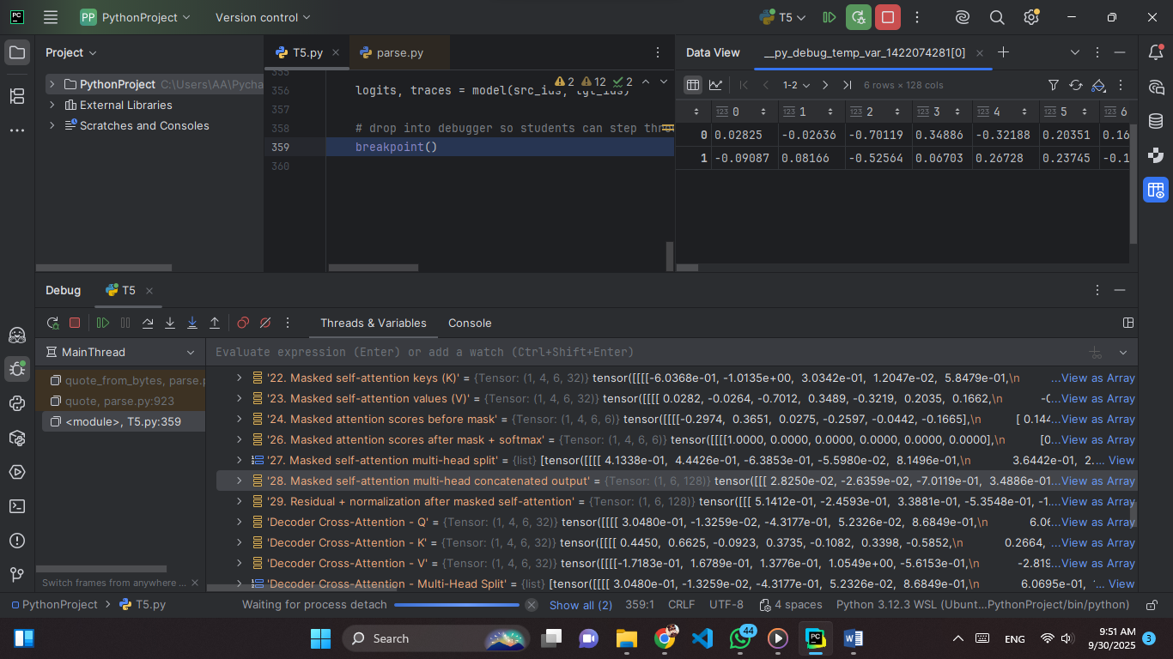**Snapshot 28: Masked self-attention multi-head concatenated output**

**Explain:** This tensor represents the output after the individual attention head outputs have been concatenated back together. Each head learns different contextual patterns, and concatenation merges them into a single unified representation. This step restores the hidden dimension of the model and prepares the data for the following linear projection, which fuses the information from all heads into one combined space.

**Values:**  
0.02825, -0.02636, -0.70119, 0.34886, -0.32188, 0.20351, 0.16620,   
-0.09087, 0.08166, -0.52564, 0.06703, 0.26728, 0.23745, -0.15051,   
(values range from about −1.95 to +1.70).

**Tensor:** Shape (1, 6, 128) → 1 sequence, 6 tokens, 128 combined features (from 4 heads × 32 features per head).

**Snapshot 29: Residual + Normalization after Masked Self-Attention**

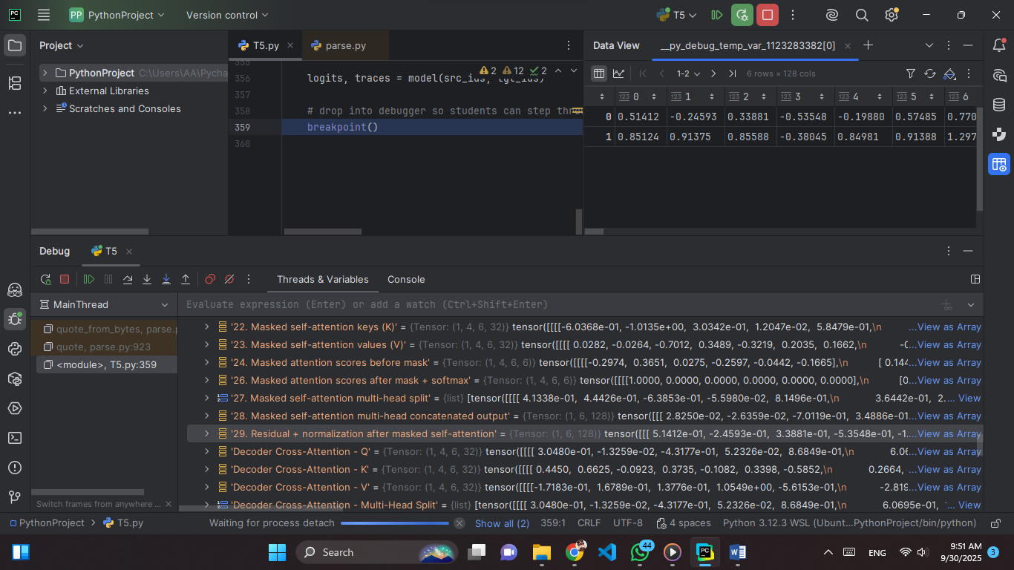

**Explain:** This tensor represents the hidden states after applying the residual connection (adding the input back to the masked self-attention output) and then normalizing the result. The residual connection helps preserve original input information, while normalization ensures stability and balanced scaling of activations before entering the feed-forward sublayer.

**Values(just part):**  
0.51412, -0.24593, 0.33881, -0.53548, -0.19880, 0.57485, 0.77044,  
0.85124, 0.91375, 0.85588, -0.38045, 0.84981, 0.91388, 1.29764,  
  
(values range from about −2.50 to +3.21).

**Tensor:** Shape (1, 6, 128) → 1 sequence, 6 tokens, 128 hidden features after residual + normalization.

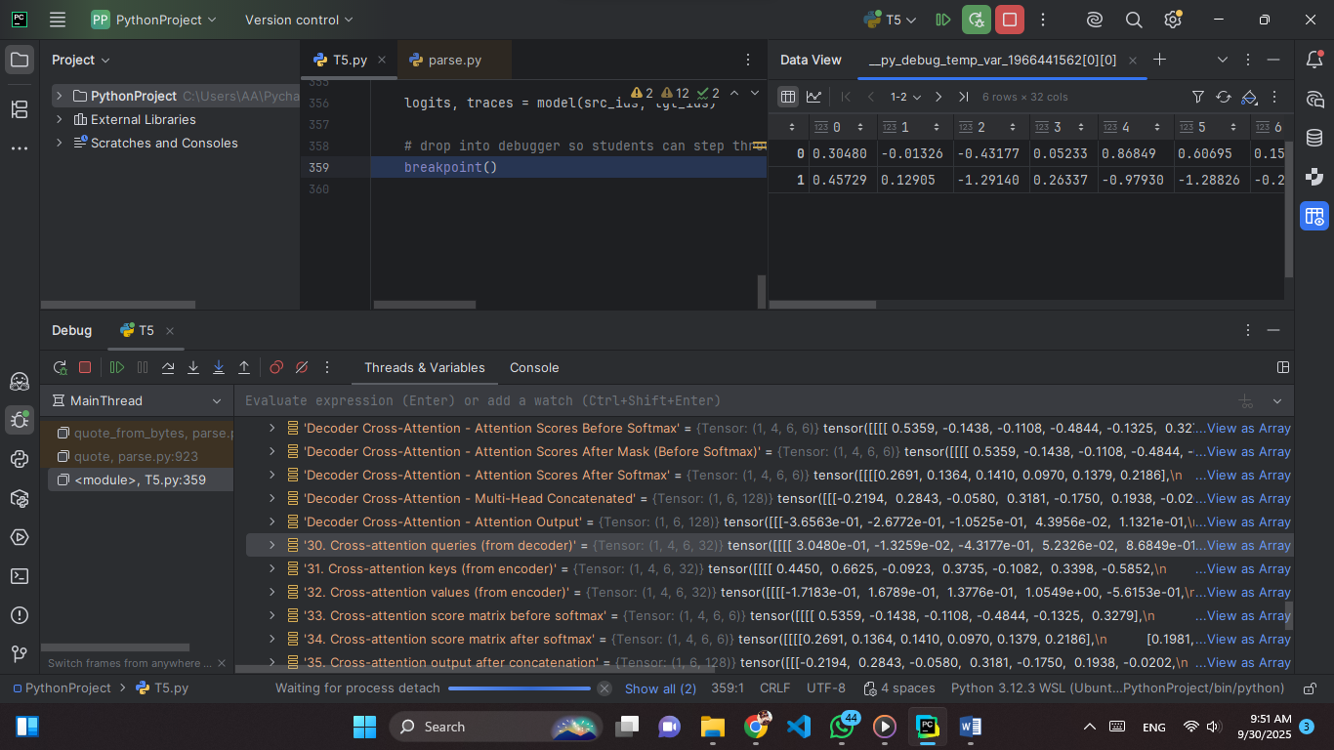**Snapshot 30: Cross-attention queries (from decoder)**

**Explain:** This tensor represents the query vectors produced by the decoder for cross-attention. Each query encodes how the decoder positions will attend to the encoder outputs. Queries capture the decoder-side context that will be compared with encoder keys during attention score calculation.

**Values (just part):**  
0.30480, -0.01326, -0.43177, 0.05233, 0.86849, 0.60695,  
0.15299, -0.06363, 1.41928, 0.73798, 0.11272, 0.03447,

(values range from about −1.38 to +1.57).

**Tensor:** Shape (1, 4, 6, 32) → 1 sequence, 4 heads, 6 tokens, 32 hidden features per head (queries).

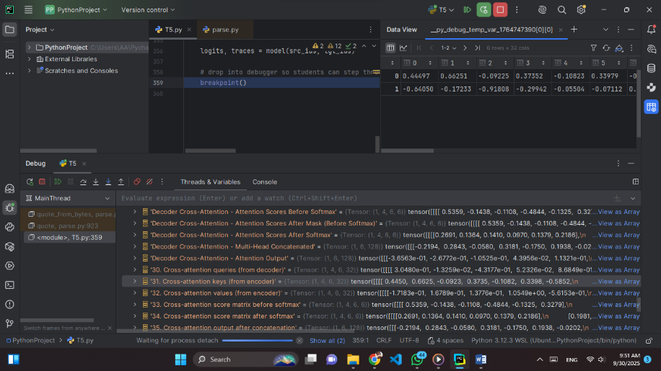**Snapshot 31: Cross-attention keys (from encoder)**

**Explain:** This tensor contains the key vectors produced by the encoder. Keys represent the encoded source information, which the decoder queries will compare against during cross-attention. They define the positions and features in the source sequence that can be attended to.

**Values (just part):**  
0.44497, 0.66251, -0.09225, 0.37352, -0.10823, 0.33979,  
-0.58520, 0.26643, -0.33708, 0.96053, 0.41135, -0.04132,

(values range from about −1.52 to +1.01).

**Tensor:** Shape (1, 4, 6, 32) → 1 sequence, 4 heads, 6 tokens, 32 hidden features per head (keys).

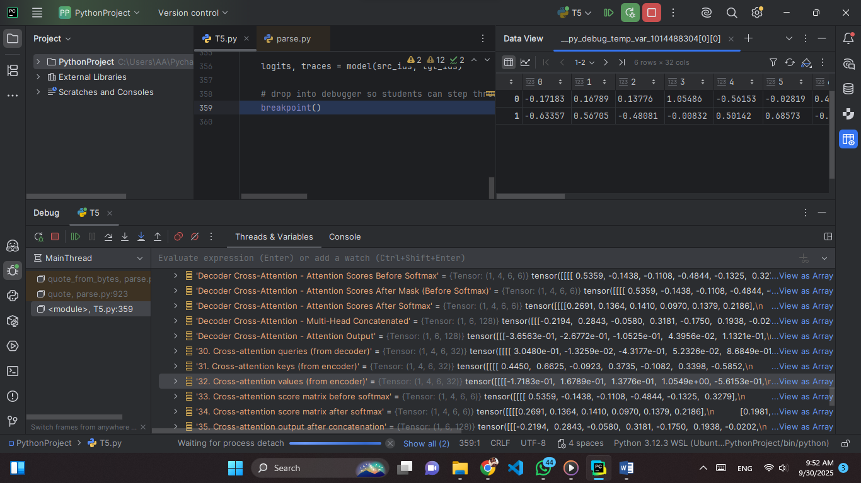**Snapshot 32: Cross-attention values (from encoder)**

**Explain:** This tensor contains the value vectors from the encoder, which provide the actual content retrieved when the decoder queries attend to the keys. Values carry the source information passed into the cross-attention mechanism.

**Values (just part):**  
-0.17183, 0.16789, 0.13776, 1.05486, -0.56153, -0.02819,  
0.44596, -0.11556, -0.86809, 1.51668, 0.09181, 0.12737,

(values range from about −1.45 to +1.52).

**Tensor:** Shape (1, 4, 6, 32) → 1 sequence, 4 heads, 6 tokens, 32 hidden features per head (values).

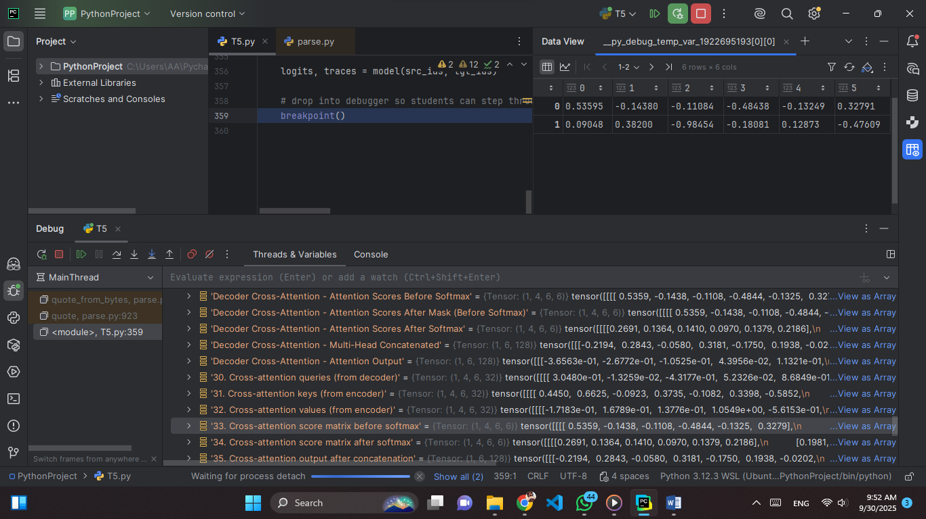**Snapshot 33: Cross-attention score matrix before softmax**

**Explain:** This tensor holds the raw similarity scores between decoder queries and encoder keys, before applying the softmax. These scores determine how strongly each decoder token attends to different encoder tokens.

**Values:**  
0.53595, -0.14380, -0.11084, -0.48438, -0.13249, 0.32791,  
0.09048, 0.38200, -0.98454, -0.18081, 0.12873, -0.47609,

(values range from about −0.98 to +0.54).

**Tensor:** Shape (1, 4, 6, 6) → 1 sequence, 4 heads, 6 decoder tokens × 6 encoder tokens (attention scores).

**Snapshot 34: Cross-attention score matrix after softmax**

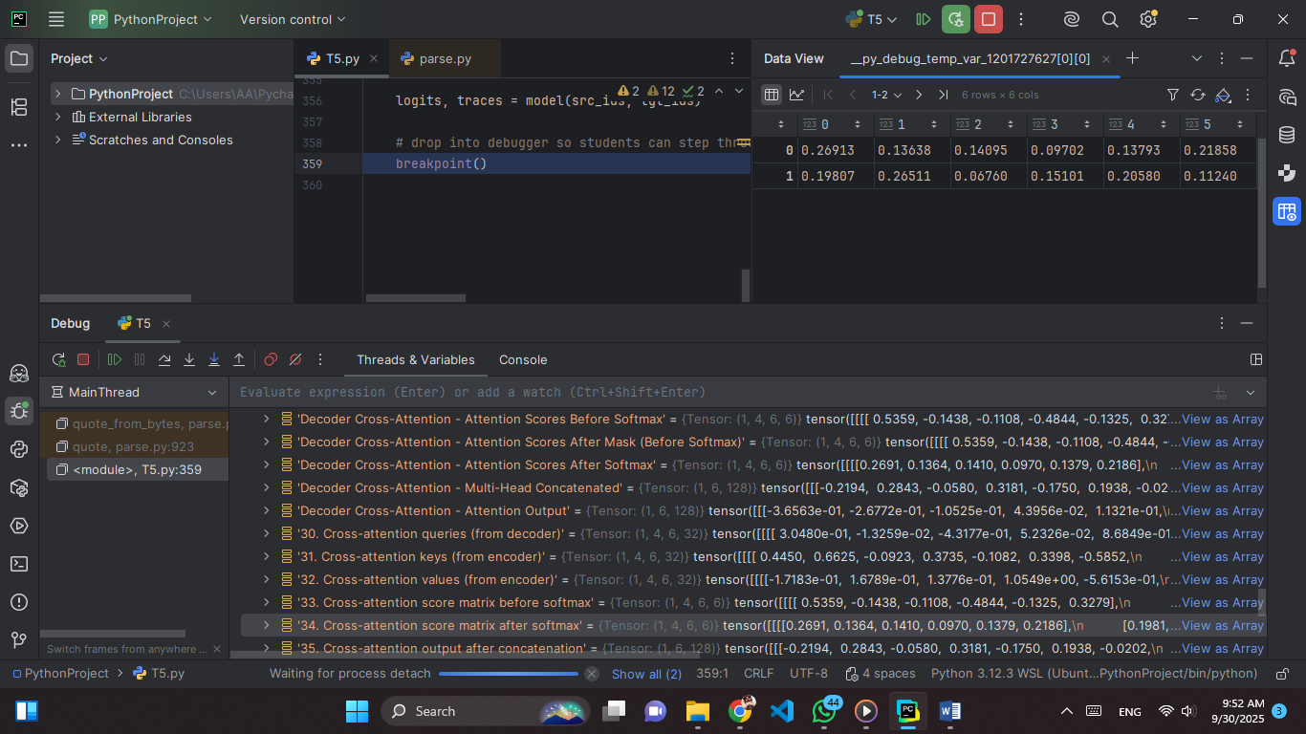

**Explain:** This tensor represents the normalized attention weights after applying softmax to the score matrix. Each row sums to 1, showing the probability distribution over encoder tokens that the decoder focuses on.

**Values:**  
0.26913, 0.13638, 0.14095, 0.09702, 0.13793, 0.21858,  
0.19807, 0.26511, 0.06760, 0.15101, 0.20580, 0.11240,

(values range from about 0.07 to 0.27).  
**Tensor:** Shape (1, 4, 6, 6) → 1 sequence, 4 heads, 6 decoder tokens × 6 encoder tokens (normalized attention weights).

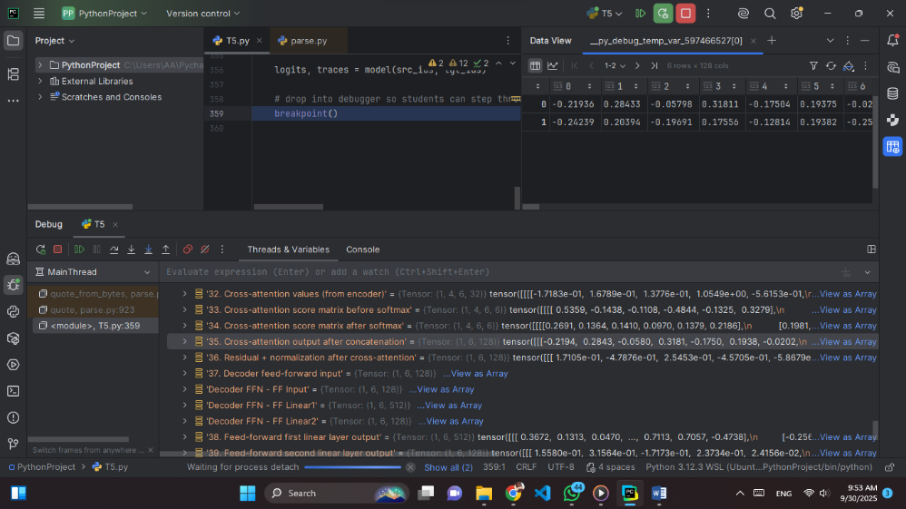**Snapshot 35: Cross-attention output after concatenation**

**Explain:** This tensor represents the combined output of all attention heads after concatenation. Each token’s attended information from the encoder is merged into a single vector, preserving contributions from multiple heads before the final projection.

**Values (just part):**  
-0.21936, 0.28433, -0.05798, 0.31811, -0.17504, 0.19375,  
-0.02016, -0.07870, -0.27212, 0.40094, 0.06191, 0.12740,

(values range from about −0.72 to +0.80).

**Tensor:** Shape (1, 6, 128) → 1 sequence, 6 tokens, 128 hidden features (concatenated multi-head outputs).

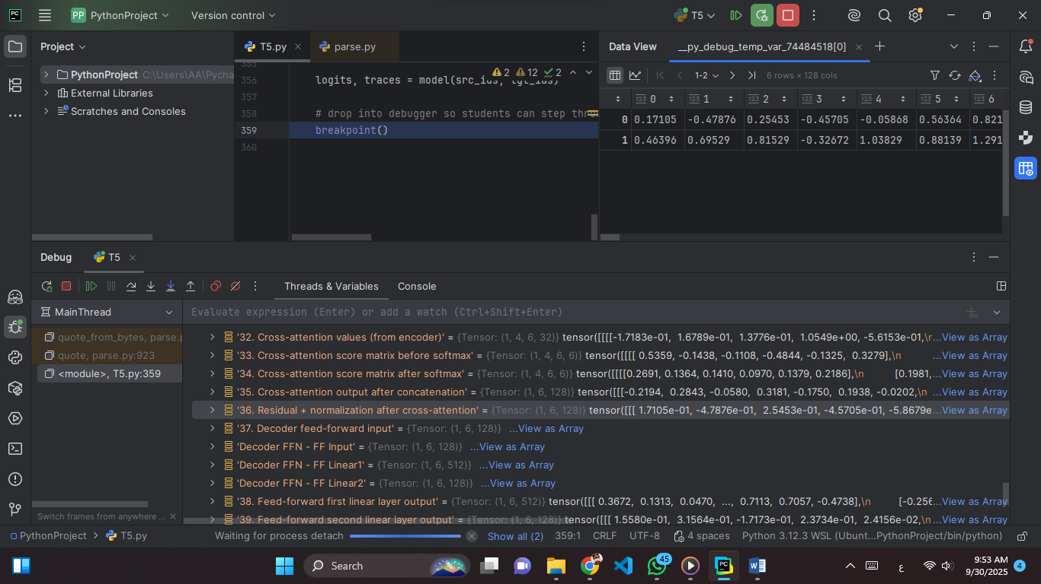**Snapshot 36: Residual + normalization after cross-attention**

**Explain:** This tensor represents the hidden states after adding the cross-attention output back to the decoder input (residual connection) and applying layer normalization. The residual preserves input information, while normalization stabilizes activations for the next sublayer.

**Values (just part):**  
0.17105, -0.47876, 0.25453, -0.45705, -0.05868, 0.56364,  
0.82191, 0.36414, 0.40044, 0.54807, -0.40212, -1.61175,

(values range from about −2.40 to +3.17).

**Tensor:** Shape (1, 6, 128) → 1 sequence, 6 tokens, 128 hidden features after residual + normalization.

**Snapshot 37: Decoder feed-forward input**

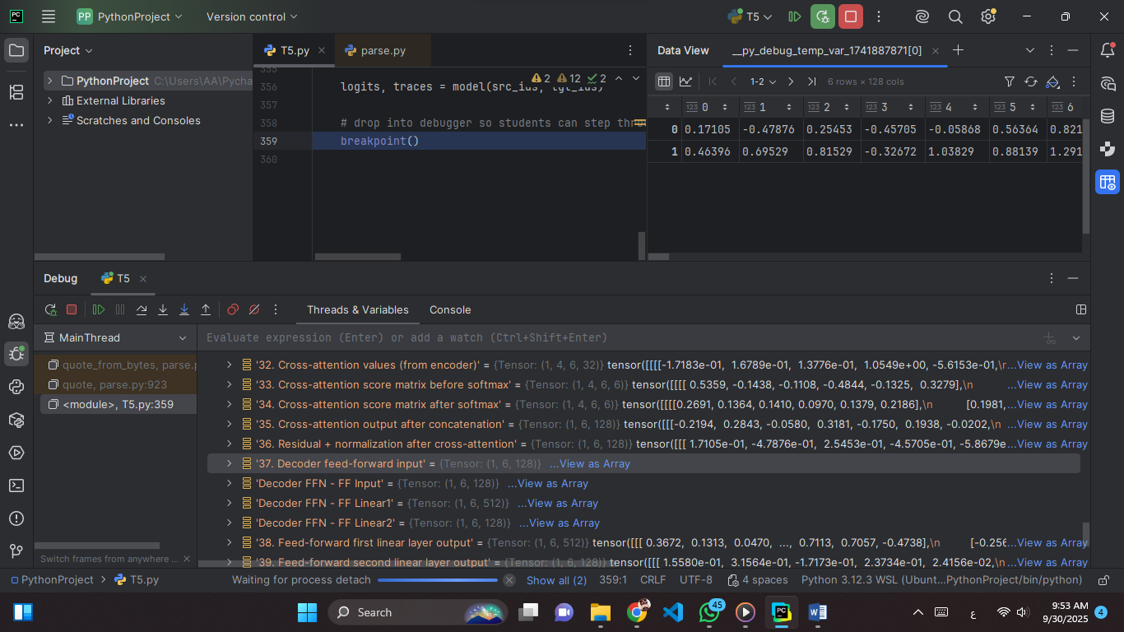

**Explain:** This tensor is the input to the decoder’s feed-forward network, taken directly from the residual + normalization after cross-attention. It represents token-level hidden states prepared for non-linear transformation by the feed-forward layers.

**Values (just part):**  
0.17105, -0.47876, 0.25453, -0.45705, -0.05868, 0.56364,  
0.82191, 0.36414, 0.40044, 0.54807, -0.40212, -1.61175,

(values range from about −2.40 to +3.17).

**Tensor:** Shape (1, 6, 128) → 1 sequence, 6 tokens, 128 hidden features (input to feed-forward).

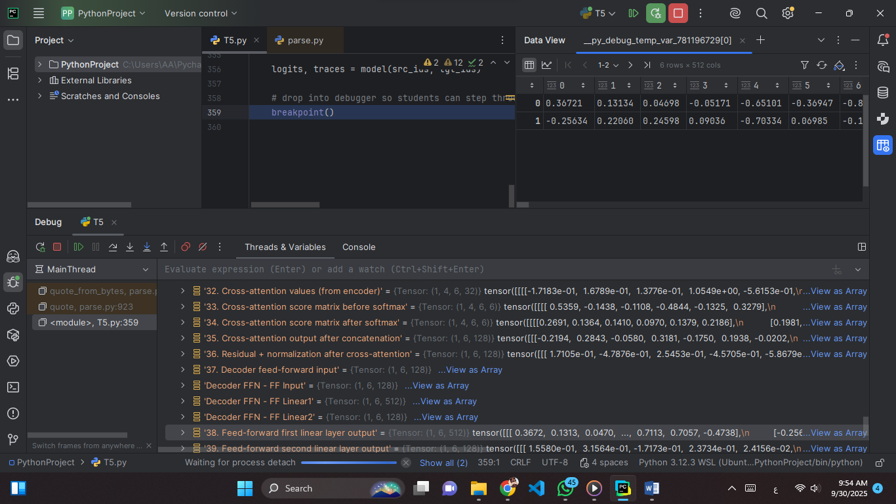**Snapshot 38: Feed-forward first linear layer output**

**Explain:** This tensor shows the hidden states after passing through the first linear transformation of the decoder’s feed-forward network. The projection expands the feature space, enabling richer non-linear representations before activation.

**Values (just part):**  
0.36721, 0.13134, 0.04698, -0.05171, -0.65101, -0.36947,  
-0.83443, -0.13174, 0.57034, 0.88948, -0.18987, -0.19234,

(values range from about −1.86 to +1.89).  
**Tensor:** Shape (1, 6, 512) → 1 sequence, 6 tokens, 512 hidden features after the first feed-forward linear projection.

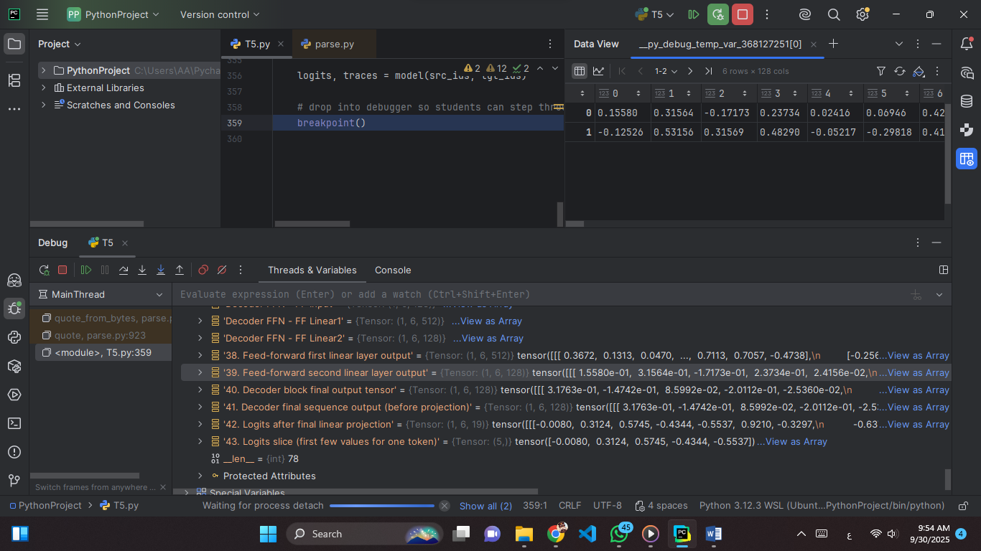**Snapshot 39: Feed-forward second linear layer output**

**Explain:** This tensor is the output after the second linear transformation of the decoder’s feed-forward network. It reduces the hidden dimension (from 512 to 128), compressing the expanded features back into a manageable size while preserving key learned patterns.

**Values (just part):**  
0.15580, 0.31564, -0.17173, 0.23734, 0.02416, 0.06946,  
0.42204, 0.11985, 0.06664, 0.08163, -0.29389, -0.27240,

(values range roughly between −0.69 and +0.53).

**Tensor:** Shape (1, 6, 128) → 1 sequence, 6 tokens, 128 hidden features after dimensionality reduction.

**Snapshot 40: Decoder block final output tensor**

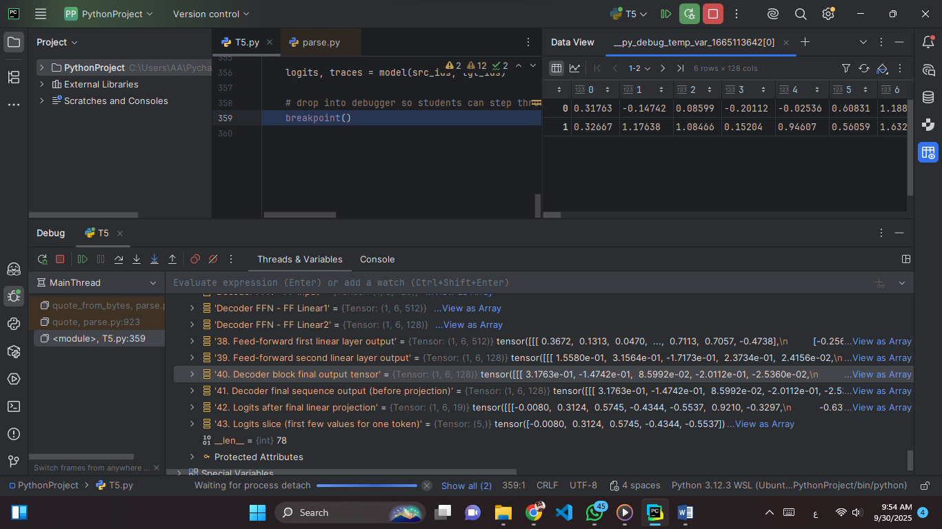

**Explain:** This tensor is the final output of the decoder block, after attention, feed-forward, residual, and normalization steps. It represents the refined hidden states for each token, ready to be passed to the next decoder layer or the output projection.

**Values (just part):**  
0.31763, -0.14742, 0.08599, -0.20112, -0.02536, 0.60831,  
1.18809, 0.46678, 0.45073, 0.60508, -0.65320, -1.78091,

(values range roughly between −2.29 and +2.20).

**Tensor:** Shape (1, 6, 128) → 1 sequence, 6 tokens, 128 hidden features after completing the decoder block.

**Snapshot 41: Decoder final sequence output (before projection)**

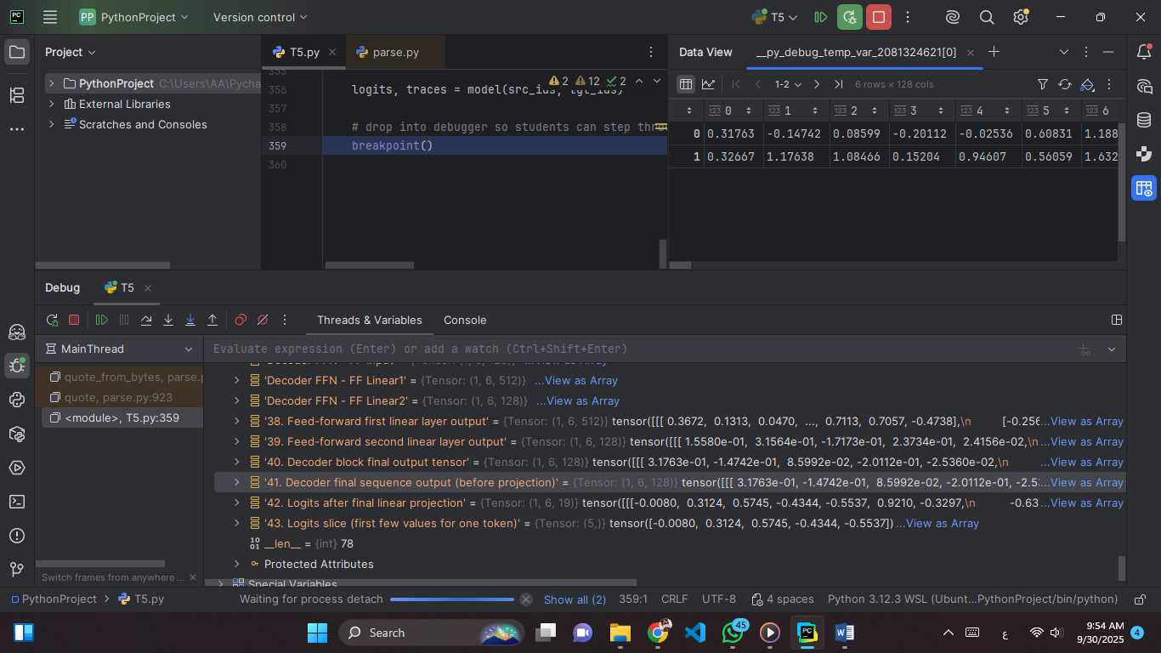

**Explain:** This is the decoder’s final hidden state output, just before applying the linear projection into logits. It encodes semantic features of tokens across the sequence.

**Values (just part):**  
0.31763, -0.14742, 0.08599, -0.20112, -0.02536, 0.60831,  
1.18809, 0.46678, 0.45073, 0.60508, -0.65320, -1.78091,

(values span about −1.78 to +1.63).

**Tensor:** Shape (1, 6, 128) → batch size 1, sequence length 6, hidden size 128 (final decoder representation).

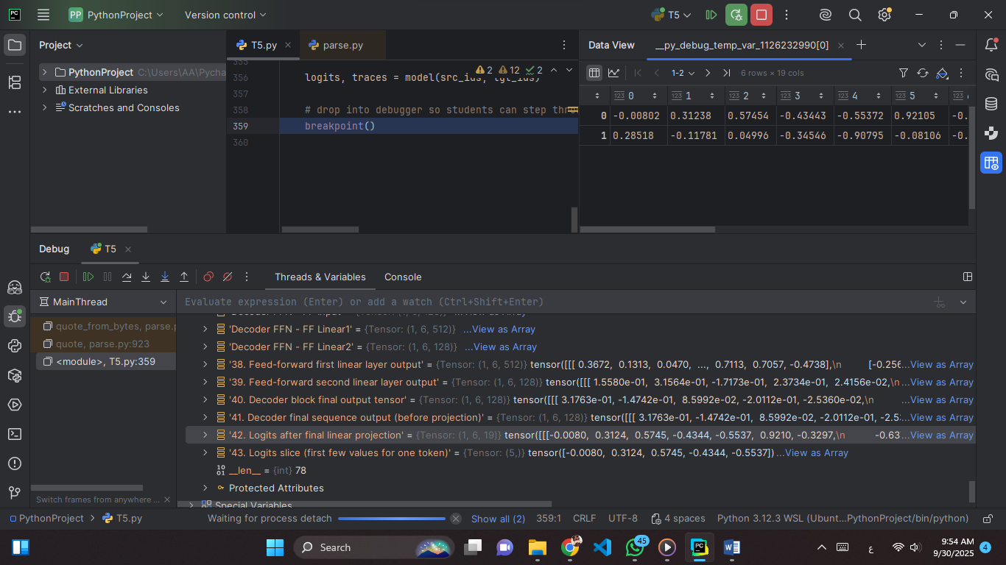**Snapshot 42: Logits after final linear projection**

**Explain:** These are the raw, unnormalized scores produced by projecting the decoder’s hidden states into the vocabulary space. Each value corresponds to the model’s affinity for a specific token before applying softmax.

**Values (just part):**  
-0.00802, 0.31238, 0.57454, -0.43443, -0.55372, 0.92105,  
-0.32973, -0.63715, 0.24487, -0.63442, -0.70326, -1.07644,

(values range roughly from −1.08 to +0.92).

**Tensor:** Shape (1, 6, 19) → batch size 1, sequence length 6, vocabulary logits of size 19.

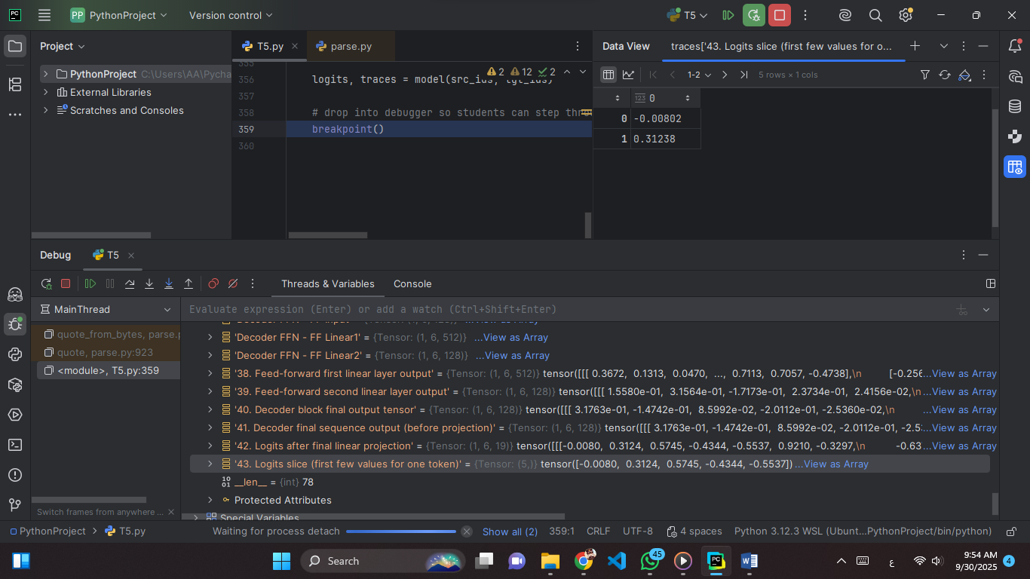**Snapshot 43: Logits slice (first few values for one token)**

**Explain:** A small slice of the logits vector for a single token. Each number is an unnormalized score for one possible vocabulary token before softmax.

**Values:**  
-0.00802, 0.31238

**Tensor:** Shape (5,) → logits for 5 vocabulary tokens.

## **Guiding Questions (Must be Answered Alongside Snapshots)**

**1. What do each of the dimensions represent at embedding, attention, feed-forward, and output stages?**

* Embedding: (batch, seq, d_model) → token vectors.
* Attention: (batch, heads, seq, d_k/v) for Q, K, V.
* Feed-forward expands/reduces, output returns (batch, seq, d_model).

**2. Why do Q, K, V tensors have the same shape, and why are they split into heads?**

* Same shape so dot products align properly.
* Split into heads for parallel subspace learning.
* Captures diverse relationships across tokens.

**3. What do the attention score matrices represent, and why must they be square?**

* They show similarity between queries and keys.
* Square so each token can attend to all tokens.
* Rows = queries, columns = keys.

**4. Why is masking necessary in the decoder, and how does the mask tensor enforce it?**

* Prevents tokens from seeing future context.
* Mask sets future scores to -∞ before softmax.
* Enforces left-to-right causal prediction.

**5. How do residual connections and layer normalization ensure consistency of shapes across blocks?**

* Residual adds input to output → same shape.
* Normalization stabilizes scale and variance.
* Together, they keep dimensions aligned.

**6. Why must the embedding dimension remain constant through all layers?**

* Needed for residual connections to work.
* Keeps representation space consistent.
* Allows smooth stacking of many layers.

**7. How does the final projection connect decoder output to vocabulary logits?**

* Linear map transforms d_model → vocab size.
* Each position gets logits for all tokens.
* Softmax converts logits to probabilities.